Jess Esplin

Due 12/15/2020

PS904 AP Seminar

Final Project: Qualitative Data Analysis

Selected qualitative data, including local radio shows, local news reporting, and public engagement on social media for both, as well as national sample of tweets, to compare public thought on the Black Lives Matter movement between March 1 and July 15, 2020 in Salt Lake City, UT and Provo, UT.

1. RADIO SHOW SELECTION

Talk radio shows in Salt Lake City and Provo in the relevant time period were not available via course resources on Cortico. I chose radio programs based on prominent thought leader radio stations: KUER public radio in SLC (liberal-leaning), KSL Newsradio (conservative-leaning) in SLC, and BYU Radio (conservative-leaning) in Provo. I could not identify any relevant talk radio sources in these locations in the traditional sense of talk radio, in which members of the public call in and discuss topics with radio hosts. Despite this, I believe these radio shows generally reflect the way their audiences are thinking about issues of the day and act as “thought leaders” to further shape public thought on these issues. Furthermore, these programming formats are becoming more common as podcasts take larger proportions of the American public’s media and information consumption and finding ways to investigate public engagement with these modes of communication are necessary to adapt to the changing media landscape. I argue social media posts and online engagement provide a way to investigate radio and podcast engagement with the public.

Salt Lake City, UT

* RadioWest (KUER Public Radio, Spotify)
  + 6/5/2020 Ibram X Kendi: How to Be an Antiracist
    - https://radiowest.kuer.org/post/ibram-x-kendi-how-be-antiracist
  + 6/11/2020 What Defunding The SLC Police Could Mean
    - https://radiowest.kuer.org/post/what-defunding-slc-police-could-mean
  + 6/11/2020 Mormonism And White Supremacy
    - https://radiowest.kuer.org/post/mormonism-and-white-supremacy
* The JayMac Show / The JayMac Podcast (KSL Newsradio originally, Spotify presently)
  + 7/6/2020 Who should apologize, President Trump or Bubba Wallace?
    - https://open.spotify.com/episode/3cCtsTACQuyYi5tMaukhYw?si=bcF4MKh6SCyJs5ldlvfSJw
  + 7/10/2020 Was the SLC police shooting justified?
    - https://open.spotify.com/episode/5uDD4VnfAc6GVQPBJ6yv3Z?si=ebXJ8IagQk6zCgHDQpQLoQ
  + 7/13/2020 Should officers have to leave their guns to buy ice cream?
    - https://open.spotify.com/episode/60wrQelmDfaSOuvcD75Qlj?si=CYbVVPjOQ7-plPYl93ndRA

Provo, UT

* The Lisa Show (BYU Radio, Spotify limited)
  + 6/5/2020 Uncertainty, True Crime, Murals and COVID-19, Sleep Schedules, Summer Eating, Eating Takeout, Weekend Review
    - https://www.byuradio.org/episode/d404a781-1111-4c65-aebb-4d4d818b2db6/the-lisa-show-uncertainty-true-crime-murals-and-covid-19-sleep-schedules-summer-eating-eating-takeout-weekend-review
* Top of Mind with Julie Rose (BYU Radio, Spotify limited)
  + 5/28/2020 Hong Kong, Jon the Robot, Race and Film
    - https://www.byuradio.org/episode/71e0c8d3-33d6-4763-af32-b9cf0df436ee/top-of-mind-with-julie-rose-hong-kong-jon-the-robot-race-and-film
  + 6/3/2020 Police Force, Antarctica Forest, Impostures
    - https://www.byuradio.org/episode/509024fa-dcc5-4c69-a3b7-f19c8b251eed/top-of-mind-with-julie-rose-police-force-antarctica-forest-impostures
  + 6/4/2020 What Whites Need To Know, Missing Strangers, Musical Theatre
    - https://www.byuradio.org/episode/4207318d-d115-4119-9ae8-0c0649c5bc89/top-of-mind-with-julie-rose-what-whites-need-to-know-missing-strangers-musical-theatre
  + 6/8/2020 Title IX, Protests, Wilderness Survival Exam
    - https://www.byuradio.org/episode/18a7fd9c-c9c6-4353-b57c-cbcb9cc152a3/top-of-mind-with-julie-rose-title-ix-protests-wilderness-survival-exam
  + 6/11/2020 The End of Policing, Racism and Health, Tombstone
    - https://www.byuradio.org/episode/7ef538db-0cc8-4eee-bcb5-fa1aabc3bef2/top-of-mind-with-julie-rose-the-end-of-policing-racism-and-health-tombstone
  + 6/17/2020 LGBT Ruling, Juneteenth, How to Breathe
    - https://www.byuradio.org/episode/464e40f4-efb0-42b8-ab8e-885ed1e9f583/top-of-mind-with-julie-rose-lgbt-ruling-juneteenth-how-to-breathe
  + 6/19/2020 Washington's Slave, Reparations, Hot Cities
    - https://www.byuradio.org/episode/e034e3b4-04c9-4908-bc9c-2c2691501b6c/top-of-mind-with-julie-rose-washington-s-slave-reparations-hot-cities
  + 6/29/2020 Police Training, Satellite Crowding, The Glass Cliff
    - https://www.byuradio.org/episode/418389a8-0eaa-4a14-ae6d-93aba71f4f01/top-of-mind-with-julie-rose-police-training-satellite-crowding-the-glass-cliff

2. NEWS REPORTING SELECTION

I also analyze local news reporting in Salt Lake City and Provo to understand how local news outlets are reporting on the Black Lives Matter and provide a comparison for the radio programs. I also look at their social media engagement with the public across different platforms to gauge how the public receives and interprets this information. I identified local news outlets to evaluate based on the most popular and accepted news sources in the area, with some variation in partisan ideological leanings. I could only identify one local news source in Provo comparable to the four local outlets in Salt Lake City.

Salt Lake City, UT

* KUER (liberal-leaning)
* The Salt Lake Tribune (liberal-leaning)
* KSL News (conservative-leaning)
* Deseret News (conservative-leaning)

Provo, UT

* Daily Herald (conservative-leaning)

QUALITATIVE ANALYSIS: QUOTES, OBSERVATIONS, & ANALYSIS

SECTION I: RADIO SHOW ANALYSIS

1. SALT LAKE CITY, UT RADIO SHOWS

RadioWest

6/5/2020 Ibram X Kendi: How to Be an Antiracist

<https://radiowest.kuer.org/post/ibram-x-kendi-how-be-antiracist>

* Relevant quotes:
  + 1:34 “Friday after work, you know, I found myself streaming the images coming out of Atlanta and watching the protests happening there. That’s where I’m from, that’s where I’ve spent the past few years of my life. And I remember having a unique thought Friday night – there’s no way – this will never get to Salt Lake City. [overlaid with audio from a Black Lives Matter protest in SLC]. I didn’t expect to see the turnout that I saw. I didn’t expect to see the wide arrange[sic] of races that I saw. And to see the wide range of people, I mean more than 1,000 protestors be willing to do this, to do this on foot, to interrupt traffic, that was really shocking to see – one, as a new person in this state, but two as a journalist covering this state. What I found here was – being a Black journalist in Salt Lake City – there was really interesting conversations being had because now I’m covering people who are, in a sense, telling me about my own experience. [Interview audio overlay: “Candace, I’m from Utah”]. I talked to one woman who became emotional and she says… [Interview overlay: “They’re supposed to be serving us and protecting us. Us.”]. Police swore to protect us. [Interview overlay: “They’re killing us. And that’s not fine.”]. Us, gesturing at me and you, not just me, not just Utahns, but all of us, no matter what your race or how you identify. As a journalist, in that moment, you can’t correct them and you aren’t supposed to input your opinion, like no this is how this actually goes. So it’s fascinating to kind of watch them toe this line of how they were phrasing what they were saying and the emotions that they put behind it. [Interview overlay (with a new voice): “I’m passionate about people living a life and not being afraid to be who they are.”]. I talked to one guy who was like, I’m here because George Floyd can’t be. [Interview overlay: “Because I get to go home tonight. I get to hug my kids tonight. I get to wake up tomorrow. He doesn’t. And the only reason that that was him and not me was because of the color of our skin.”]. Now I’m here to speak up because I get to go home and hug my kids and we can talk about our privilege and he doesn’t have that same idea. So you really saw the community come together and kind of that mantle being shared that for African Americans who are protesting police brutality and racial injustice, you aren’t in this fight alone. [overlaid with audio from a Black Lives Matter protest in SLC]. You know, I still leave my house everyday as a Black man in America. And I was angry as well. I was upset. It’s like keep do what you’re doing, I get it. When I see violent events, when I see people being shot and killed by neighborhood vigilantes such as the Ahmaud Arbery case, that takes a piece of you. That could’ve been my story. I lived in Georgia. I ran on these roads so many times in communities that look nothing like me. I think where I’m at now is how do we reflect the next steps and the next actions and get people who are allies and who are a part of the movement news that they can actually use to become better citizens. And when we figure that out, I think we will have done something beyond just reporting on the news, but actually giving people a handbook to how to maneuver through the situation.” – Ross Terrell
* Observations:
  + Solicited statements from 3 nonwhite (all Black?) employees at KUER about their thoughts on the Black Lives Matter movement and protests and all of them shared personal experiences
  + Interview with Dr. Ibram X Kendi revolved around suggestions for how to interpret current events in historical context and actions that one can take to combat racism
* Analysis:
  + Spotlights Black employees’ perspectives on the movement and reaction in Salt Lake City
  + Generally in support of the Black Lives Matter movement, in line with most of the radio programs’ perspectives on this

The JayMac Show

7/6/2020 Who should apologize, President Trump or Bubba Wallace?

<https://open.spotify.com/episode/3cCtsTACQuyYi5tMaukhYw?si=bcF4MKh6SCyJs5ldlvfSJw>

* Relevant quotes:
  + 1:45 “And unfortunately, politics have crept their way into our sports because of protest and because the President and others have decided to chime in on what’s happening within specific sports, bringing new attention to these sports, and also bringing, what I consider, new divisions” – Jay McFarland
  + “…you find moments where the president sough to unite, not to divide. President Lincoln, in his second inaugural address, when the nation was divided in civil war, in his speech, he talked about malice towards none and charity for all. He could’ve used that opportunity to divide and to create hatred. He sought to bring together and to unify. And that’s what should be happening in our trials that we are facing right now. The trials that we are facing over the racial divide. The trials that we’re facing over the pandemic. We should be coming together as a nation. We should be united in a cause that fights freedom and equal and fair treatment for all and that fights for the return of this country to greatness by reopening but doing so in a way that protects everybody and keeps as many people alive as possible.” – Jay McFarland
* Observations:
  + Surprisingly (to me), Jay does not portray Bubba Wallace negatively and suggests President Trump should’ve handled this conflict better
  + He sort of vaguely refers to a bad event that we must unify over, which could be interpreted as the killing of unarmed Black men by police or the noose being left in Bubba Wallace’s locker
  + Uses an interview with Senator Lindsay Graham (not conducted by Jay McFarland) to illustrate the point he wants to make that it is a natural reaction for Bubba Wallace to be upset about finding a noose in the locker room and it’s a good business decision for NASCAR and the best decision for the sport of racecar driving to ask fans not to use a symbol of division (interestingly, frames it as an ask from NASCAR, rather than a ban; the symbol in question is the Confederate flag)
* Analysis:
  + Does not directly address the Black Lives Matter movement but the events of this conflict between Bubba Wallace and President Trump revolved around accusations of racism following the protests over the summer
  + Jay seems to have a very specific point he wants to make that President Trump should do be doing more to unify the country and not cause further division
    - It seems to me that he is trying very hard to convince his listeners of this, perhaps anticipating that they may not agree with him?

2. PROVO, UT RADIO SHOWS

The Lisa Show

(6/5/2020) Uncertainty, True Crime, Murals and COVID-19, Sleep Schedules, Summer Eating, Eating Takeout, Weekend Review

<https://www.byuradio.org/episode/d404a781-1111-4c65-aebb-4d4d818b2db6/the-lisa-show-uncertainty-true-crime-murals-and-covid-19-sleep-schedules-summer-eating-eating-takeout-weekend-review>

* Relevant quotes:
  + 1:02 “First the pandemic and now riots across the country… I feel like I can’t ever leave my house! A lot of people feel like they shouldn’t.” – Lisa Clark
  + 1:19 “Murder hornets, uh, riots, pandemic – what else are we doing?” – Richie T. Steadman
  + 5:31 “I’m willing to allow this uncertainty. I’m going to let go of trying to struggle with it. I’m going to let go of trying to confirm what’s going to happen and maybe that means not watching so much news, not, you know, obsessively scrolling your feed to see how many people died today, where were the riots. So really coming back to the present moment and accepting that you are sitting in the not knowing.” – Dr. Lara Fielding
  + 19:12 “I got your morning buzz. It’s three stories that are trending online right now. I have them for you. Allow me, if you will, to present them to you. Uh, this first one, it’s the first of three memorials for George Floyd, the man who was murdered in Minneapolis. It took place yesterday. The Reverend Jesse Jackson was on hand, as well as, um, Senator Amy Klobuchar, both in attendance, as well as Ilhan Ohmar, Sheila Jackson Lee, Ayanna Presley, and Joyce Beatty. Rappers TI along with his wife, Tiny, Ludacris, Tyrees Gibson, comedians Kevin Hart and Tiffany Haddish, as well as Marcei Martin, all in attendance. Uh, that was the memorial that took place in Minneapolis. The - he will be laid to rest, I believe, in Houston later this week. Uh, also if you remember the ‘ain’t nobody got time for that’ or ‘hide yo kids, hide yo wife’ – those songs that were created out of news pieces in the past….” - Richie T. Steadman
* Observations:
  + Only mentions a small reference to what’s going on in the world (wrt BLM movement) as premise for discussion with a clinical psychologist on mindful practices to handle uncertainty
    - Then later directly states information about George Floyd’s murder and his memorial but only as a news announcement and not part of a discussion on the topic – the co-host quickly moves on to announce other headlines of the day
  + Frames it as riot every time it is mentioned – by the host, co-host, and interviewee (clinical psychologist) – the co-host and interviewee take the host’s portrayal at its face and run with it
* Analysis:
  + Does not address my RQ: they don’t refer to any BLM-related organization because they only mention it in passing/as context for the programmed discussion
  + In general, reflects my understanding of the movement in Provo – controversial subject to be avoided, especially by women
    - Supported by lack of controversial topics on their social media pages

Top of Mind with Julie Rose

5/28/2020 Hong Kong, Jon the Robot, Race and Film

<https://www.byuradio.org/episode/71e0c8d3-33d6-4763-af32-b9cf0df436ee/top-of-mind-with-julie-rose-hong-kong-jon-the-robot-race-and-film>

* Relevant quotes:
  + 50:19 “We’ll consider how Hollywood films have shaped America’s views on race and can be a tool for starting the conversations we need to have and we need to keep having” – Julie Rose
  + 50:40 “Ahmaud Arbery and George Floyd. Both unarmed black men killed by white men. Both incidents came under scrutiny only after cellphone video was made public. Ahmaud Arbery was jogging in a Georgia neighborhood when he was shot dead by a retired law enforcement officer and his son, who have now been charged with murder. George Floyd died in Minneapolis police custody this week. Bystander video of the arrest shows Floyd on the ground, struggling to breathe as a white police officer kneels on Floyd’s neck for several minutes. The officers involved in that incident have been fired and the FBI is investigating. Video is a powerful tool to prompt scrutiny, spark outrage and, hopefully, bring change. Baylor University theologian and film scholar Greg Garrett has spent the last several years using film of a different sort to prompt scrutiny, outrage and, hopefully – change – in the way white Americans think about race.”
* Observations:
  + Guest Greg Garett discusses how it can be hard to talk about race and racism without feeling emotional and tripping up over your own feelings, but stories told through film allow us to think about these issues and talk about them without necessarily positioning ourselves in the narrative
  + Film allows white people to experience some of what Black people experience
* Analysis:
  + Overall, the show host openly acknowledges and portrays George Floyd’s death as an unjust killing, the guest seems to agree and argues for the role of video and film to combat racism in America
  + Although they do not directly address the Black Lives Matter movement, they appear to be in support of it and suggest ways to further interrogate racism and other racial injustice in the U.S.
  + No mention of any Black Lives Matter-related organizations

6/3/2020 Police Force, Antarctica Forest, Impostures

<https://www.byuradio.org/episode/509024fa-dcc5-4c69-a3b7-f19c8b251eed/top-of-mind-with-julie-rose-police-force-antarctica-forest-impostures>

* Relevant quotes:
  + 0:30 “Curfews are in effect in cities across the country, hoping to quell the violence that has accompanied protests. People are in the streets demanding reform to how police use force and how they are held accountable when they kill unarmed Black people. President Trump says governors and law enforcement need to ‘dominate’ the protestors. Videos of police officers using tear gas, rubber bullets, and batons on peaceful protestors have only inflamed tension.” – Julie Rose
  + 1:18 “So as I mentioned, President Trump argues the reason protests seem to have spiraled out of control is because cities and states aren’t being tough enough, but I wonder if cracking down harder would only bring more people to the streets, or make them behave more badly – what’s the tension there?” – Julie Rose
* Observations:
  + Guest Michael Sierra-Arévalo discusses research on protests and how police violence in response to unrest escalates or exacerbates protest violence
* Analysis:
  + Host’s framing of the protests was careful not to describe the violence as inherent to the protest: “violence that has accompanied protests” does not assign blame or responsibility for the violence to protestors or even as a result of the protests themselves
  + Host and guest both acknowledge racism and racial injustice and suggest support for the goals of equality in the Black Lives Matter movement
  + Does not address organization wrt Black Lives Matter movement but guest does talk about the goals of the abolitionist movement within broader movement as being to rethink the use of police and police force in American society

6/4/2020 What Whites Need To Know, Missing Strangers, Musical Theatre

<https://www.byuradio.org/episode/4207318d-d115-4119-9ae8-0c0649c5bc89/top-of-mind-with-julie-rose-what-whites-need-to-know-missing-strangers-musical-theatre>

* Relevant quotes:
  + 0:30 “All four Minneapolis police officers who were on the scene when George Floyd was suffocated have now been arrested and charged with murder or aiding in the murder. Protests against racial inequality and police violence continue to fill streets across the country, with no sign of ending. We are going to spend the next few minutes talking exploring how the color of your skin may be affecting your view on the protests.” – Julie Rose
  + 1:45 “So I know there are all kinds of new white people being suddenly, newly awakened. And um it’s a hard place to be. It’s – I was there 12 years ago. I remember when I started to understand that the country that I was taught that I lived in is not the country that I live in. And it’s uh, that creates a lot of dissonance. It’s a lot easier to confirm an old belief than to challenge a belief that we have and let a new one in and I think that’s a state that a lot of people are in right now. How could this be? How in 2020, could this be?” – Debby Irving
  + 2:24 “Although we’ve certainly seen videos, um and we’ve actually, you know, seen protests against the killing of unarmed Black men by white officers, do you think there’s something different about this because of that video, because of being able to see George Floyd on the ground with an officer kneeling on his neck for 8 minutes while other officers stood by and did nothing? Do you think that, do you think that unambiguous nature of that, that it is, I would argue, impossible to watch that video and not say, that is wrong, why is that happening in America? Is that part of what’s different here, do you think?” – Julie Rose
* Observations:
  + Host frames topic at the start as consequences of police actions
  + Host describes protests with neutral or positive tone, attributes violence to police
  + Guest Debby Irving describes how George Floyd’s murder sparked public outcry in a much different way than condemnation for racial injustice has taken place in the past
    - As result of many factors: many people at home because of the pandemic are already in a state of dissonance and multiple highly publicized killings of Black people within a short time period
    - Consequence is a palpably different experience of understanding racial injustice for white people
* Analysis:
  + Host and guest discuss the experience of awakening to realities of racial injustice in our country (specific to the perspective of white people, for the most part), so this discussion appears targeted at white audiences
  + Host and guest both acknowledge racism and racial injustice and suggest support for the goals of equality in the Black Lives Matter movement
  + Does not address organizational aspect of the movement

SECTION II: RADIO SHOW SOCIAL MEDIA INTERACTION

I examine social media posts on the most popular platforms (Facebook, Twitter, Instagram) of the shows’ and/or hosts’ pages on those platforms for interactions with members of the public to determine how they are receiving the show content as it relates to the Black Lives Matter movement.

The JayMac Show:

* Social Media Accounts:
  + Facebook: https://www.facebook.com/JayMac.Mcfarland
  + Instagram: https://www.instagram.com/jaymac_for_congress/?hl=en
  + Twitter: https://twitter.com/jaymcfarland
* Observations:
  + Posts on Facebook frequently, often about politics and also about his run for a Congressional seat in the UT District 3 primary election
  + Seems to get a lot of public engagement on Facebook, particularly from listeners of his show
  + Also posts frequently on Twitter, but receives very little engagement there
  + Posts on Instagram are almost exclusive to his Congressional campaign and less engagement than Facebook
* 5/30/2020 FB Post, 161 reactions, 49 comments, 32 shares (<https://www.facebook.com/JayMac.Mcfarland/posts/3141279412680014>)
  + “People who choose violence are not protesters, they are anarchists and they need to be held accountable. To those who are protesting peacefully I say thank you. I pray for Utah tonight that cooler heads will prevail and no one will get seriously injured.”
    - Portrays some protestors in negative light, but acknowledges that not all the protestors are violent
  + Text repeated in picture format (screenshot below)
  + Comments largely in support of his portrayal of these protests, though some express disagreement; examples below:
    - I understand there's a lot of work that needs to be done to improve the lives of black people. However, seeing people destroy a police car is never the answer. I'm disappointed in my fellow Utahns.
    - The arrested protesters should be liable for all damages and lost revenue for all businesses effected.
    - There’s a huge difference between protest and riot, one is usually peaceful and one is criminal. If you choose to be criminal then ya get what ya get. Nothing says I love my fellow man like a good looting and a riot. 😐 not to mention your city... 😔
    - “Darkness cannot drive out darkness; only light can do that. Hate cannot drive out hate; only love can do that.” I know a lot of people are upset, and rightly so. The officer responsible should be punished. More should be done to eliminate police brutality. I just don’t know how more violence will makes any of this better. Destruction of property and harming other people does not cure racism, it honestly it can perpetuate it. How will those people harmed view the protestors? If their goal is to convince people that racism needs to be addressed in law enforcement they need to change hearts and minds. Attacking only makes people more closed and defensive. We need to be unified in order to combat racism, not more polarized and divided. Look at the great peacemakers, like Dr. King and Gandhi. They recognized that violence only destroys. We need healing, and more compassion.
    - Wow, imagine that. A white guy who has never been randomly pulled over and searched by police is complaining about "those rioters." Riots bring change -- just look at the Stonewall riots of 1969. The rule should be if you are white, straight and male you dost not speak.
    - Easy to say such things when we are white men. I wonder if we would feel differently watching our people die over and over again?
    - They will never get the support they need by using violence. People would have come out in the masses today if they felt they could safely. Cutting off your nose to spite your face leaves you ugly.

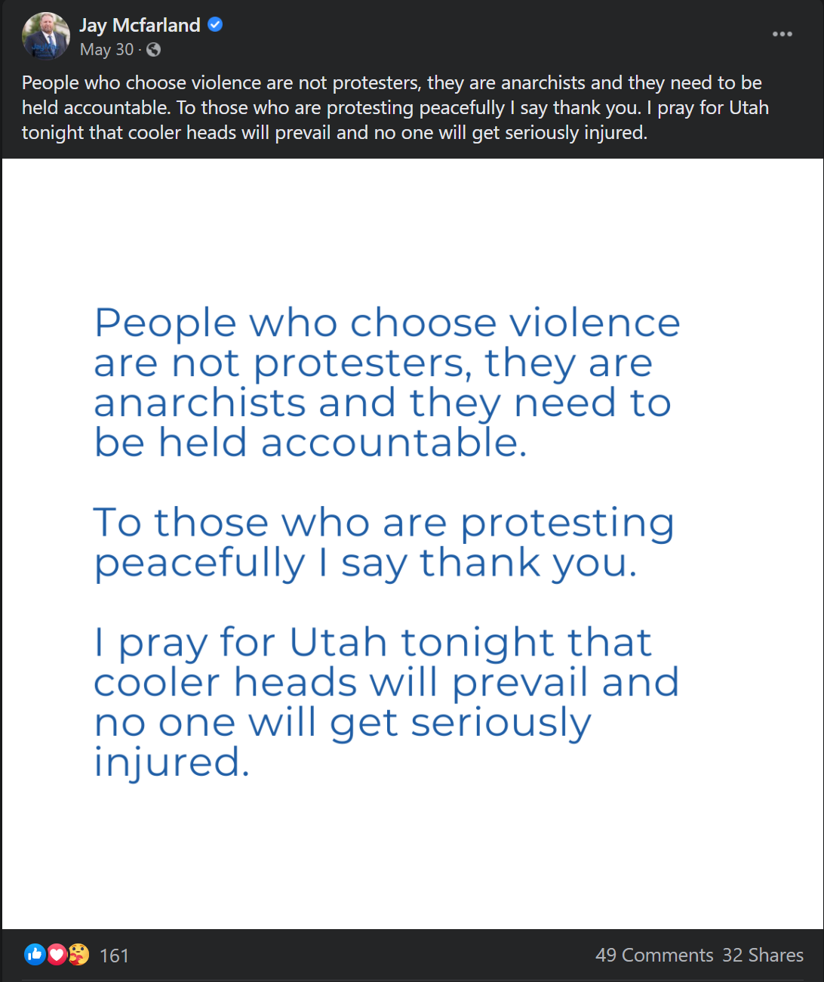

* 6/2/2020 FB Post, 75 reactions, 32 comments, 4 shares
  + https://fb.watch/22VQhk5fWh/
* 6/3/2020 FB Post, 19 reactions, 39 comments, 5 shares
  + https://fb.watch/22Wp8hq_p7/
* 7/6/2020 FB Post, (post of 7/6 podcast), 14 reactions, 75 comments, 0 shares
  + https://www.facebook.com/JayMac.Mcfarland/posts/3175773012563987
* 7/7/2020 FB Post, (repost of 7/6 podcast), 5 reactions, 32 comments, 0 shares
  + https://l.facebook.com/l.php?u=https%3A%2F%2Fwww.podbean.com%2Feau%2Fpb-fsffk-e25185&h=AT2otBKb9EqzpwAYSKKTeIjEuCbKZcue8pQTFTAuUnjABL9Ki9nwmQvRricG59rYT2tOa2uXQ7FExtkvhzCyEjfJUCm_mQosjYCgN3fx60z0jortL2mbOSYTTlpzF4kP4w&s=1
* 7/10/2020 FB Post, (post of 7/10 podcast), 12 reactions, 8 comments, 0 shares
  + https://www.facebook.com/JayMac.Mcfarland/posts/3179235372217751
* 7/13/2020 FB Post, (post of 7/13 podcast), 15 reactions, 26 comments, 1 share
  + https://www.facebook.com/JayMac.Mcfarland/posts/3181923738615581

*At time of analysis, on 11/28/2020

RadioWest:

* Social Media Accounts:
  + Facebook: https://www.facebook.com/RadioWest.KUER
  + Instagram: https://www.instagram.com/radiowest_kuer
  + Twitter: https://twitter.com/radiowest
* Observations:
  + Relatively little public engagement on Facebook and Instagram, almost none on Twitter
  + With the exception of one Instagram post in particular, listed below
* 6/16/2020 Instagram post: White on Purpose, 201k views, 1k+ comments (https://www.instagram.com/tv/CBgkE_xhsD1/?utm_source=ig_web_copy_link)
  + Reflects intense interest in intersection between white supremacy and the LDS faith and culture
* 6/1/2020 FB post (<https://www.facebook.com/RadioWest.KUER/posts/10157770041620141>)
  + “It was a hard and emotional weekend for so many of us, and what happens now remains to be seen, but we at RadioWest are proud of the reporting work done by our KUER 90.1 newsroom colleagues to keep us all informed during this difficult time. Here's the latest piece from reporter Jon Reed on the city's efforts to clean up after Saturday's protests-turned-riots.”
    - Interesting since seems like it’s trying not to pass judgement on protests until the end, when it does call them riots

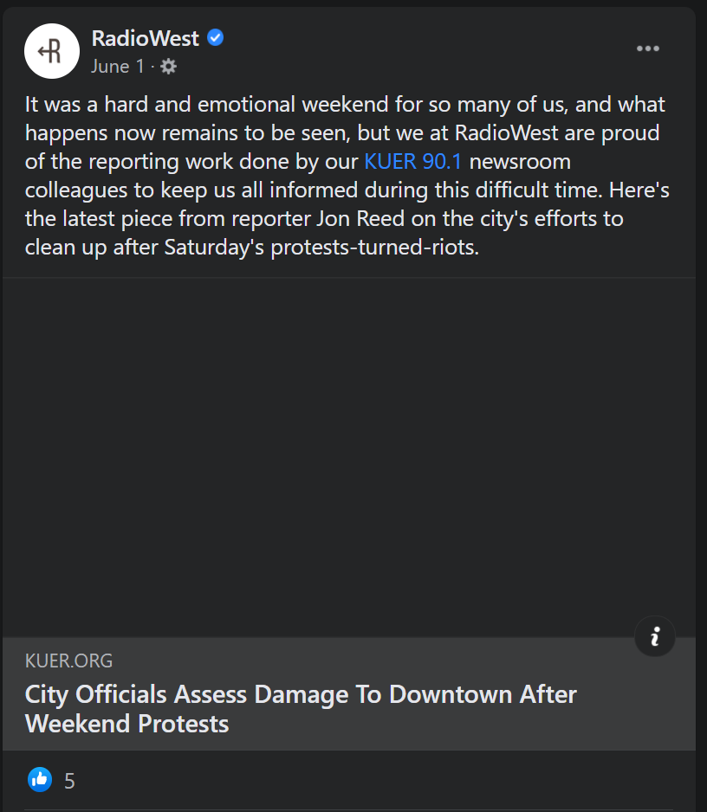

* 6/11/2020 FB post (<https://www.facebook.com/RadioWest.KUER/posts/10157801695135141>)
  + We're hearing the phrase "defund the police" more and more, including in Utah, where the Salt Lake City Council has received thousands of comments calling for police reform and reduced funding for law enforcement. Friday at 11 a.m., we'll talk with Salt Lake City Mayor Erin Mendenhall, SLC Police Chief Mike Brown, SLC Councilwoman Amy Fowler and UVU's Dr. LaShawn Williams to find out what this would mean for Salt Lake, and how city leaders are thinking about the protestors' call for action.
    - Comments:
      * I feel disappointed that not one question was asked of Chief Brown regarding Bernardo Palacios-Carbajal. I'm also disappointed that no one from Black Lives Matter, or from Decarcerate Utah, who were so instrumental in organizing the call for defunding police, were part of the conversation. DU could have probably shed some light on that $30M number.

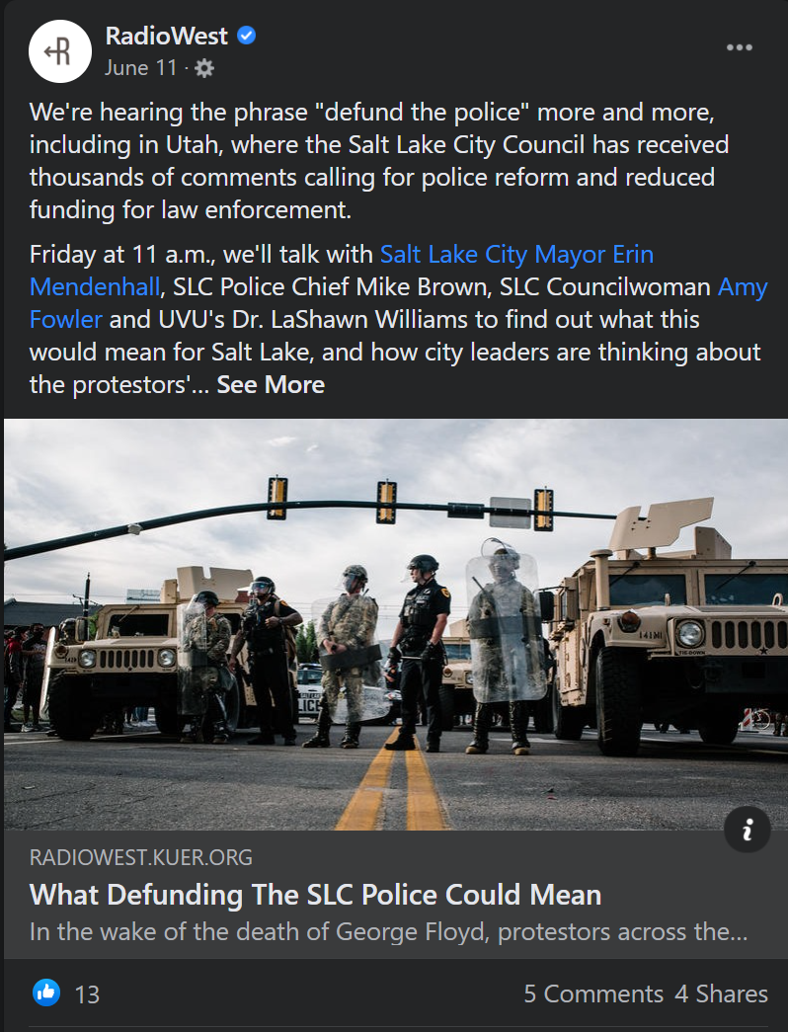

The Lisa Show:

* Social Media Accounts:
  + Facebook: https://www.facebook.com/lisavclarkshow
  + Instagram: https://www.instagram.com/lisavalentineclarkshow
  + Twitter: https://twitter.com/lisavclarkshow
* Observations:
  + No related posts on Facebook, Instagram, or Twitter
  + Also seems the show avoids controversial topics and language, both on the show and in social media posts
  + Not many comments from members of the public on any of these platforms in general
    - Suggests audience is older and/or not as closely engaged on social media, or possibly not a very close community of listeners on this show

Top of Mind with Julie Rose:

* Social Media Accounts:
  + Facebook: https://www.facebook.com/byutopofmind/
  + Instagram: https://www.instagram.com/byutopofmind/
  + Twitter: https://twitter.com/BYUTopofMind
* Observations:
  + Only 1 related post on Facebook, Instagram, or Twitter
    - 6/18/2020 Facebook post discusses Juneteenth, has 1 negative comment but no further engagement (https://www.facebook.com/byutopofmind/photos/a.1234222186624706/3138275552886017/)
      * Comment: Barack Obama failed to mention Juneteenth even one time in his entire 8 year career as President. Why is that?
      * Comment is ambiguous and could be interpreted as positive or negative (the first: implying our former president should’ve talked about this important occasion and historical event; the second: implying Juneteenth is not an important and historic holiday that ought to be celebrated)
      * Based on this Facebook user’s public content feed, I think it’s safe to assume he meant the second – his feed is very alt-Right, full of Fox News shares, pro-Trump memes, anti-Trump conspiracies, and hysteric language = interpreting this comment as negative

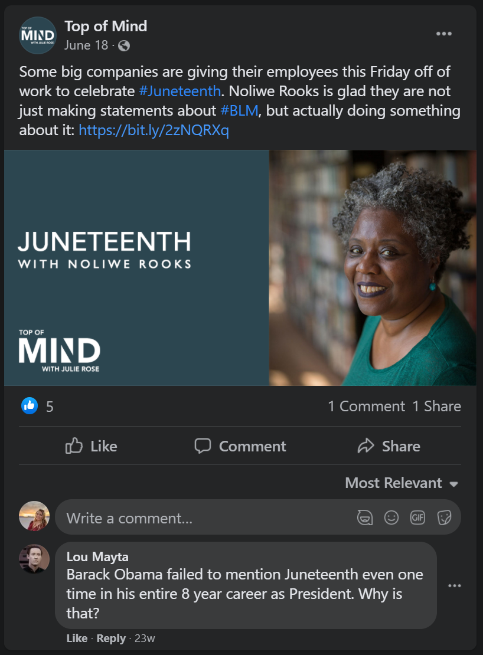



**SECTION III: NEWS REPORTING SOCIAL MEDIA ENGAGEMENT**

1. SALT LAKE CITY, UT

KUER

* 5/30/2020 Article
  + Social Media Content: (Facebook post) Originally billed as a car caravan around the Salt Lake City Police Department building, Salt Lake's march against police brutality turned into something much larger. Protesters chanted as they marched from Denver Street to police headquarters before arriving at the Utah State Capitol. The event started off peaceful from the morning into early afternoon, but turned volatile later in the day, when an overturned squad car was set on fire. Police asked people to stay away from downtown due to “civil unrest” and Gov. Gary Herbert tweeted that he had activated the Utah National Guard to help control “the escalating situation in downtown Salt Lake City.”
  + Social Media Engagement: 82 reactions, 27 comments, 14 shares; sample of comments below:
    - Old enough to remember, that often during the Civil Rights Era, many peaceful protests turned into riots because , as was later found out paid disrupters would show up and a peaceful protest would turn ugly. We've got to be careful not to be quick to judge, because there are powerful people who would like to keep our country divided, and for the White community to not have sympathy for the marginalized and oppressed people. #BlackLivesMatter
    - I do not support the violence and destruction but I understand the frustration and rage that leads to it.
    - Trash
    - Except it wasn't "billed" as a car caravan - it was organized as such. Please don't make it look like a bait-and-switch.
  + Observations:
    - Article portrays protest fairly positively, though the “originally billed” language does paint it as an event that deceived the public on how it was planned
    - Not much social media engagement in comparison to SL Tribune

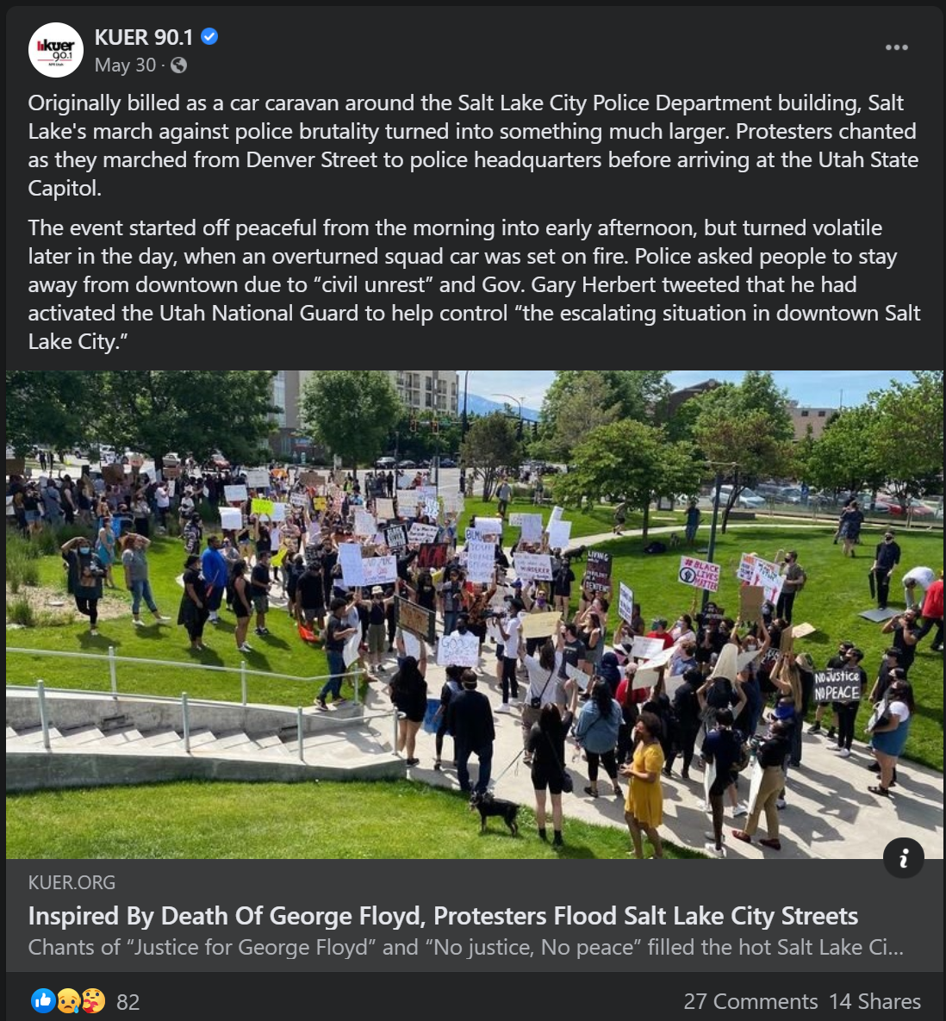

The Salt Lake Tribune

* 5/30/2020 Article: Salt Lake City is under curfew as a rally to protest death of George Floyd turns violent. Gov. Herbert activates National Guard. (https://www.sltrib.com/news/2020/05/30/rally-protests-death/)
  + Social Media Content: (Facebook post) Governor Gary Herbert said he activated the National Guard to "help control the escalating situation in downtown Salt Lake City." (https://www.facebook.com/saltlaketribune/posts/10158305416274399)
  + Social Media Engagement: 833 reactions, 576 comments, 551 shares; sample of comments below:
    - They need to get those people that were arrested go clean up all the mess. Maybe they will think twice next time to not throw trash on the ground because some one has to clean it up, and it may be them. Only fitting.
    - This veteran salutes every one of you who knowingly risk yourselves to exposure to the pandemic to stand for justice. That's the America I served to defend and preserve. 🙌 respect. Please isolate yourselves responsibly when you're finished.
    - I just passed by the demonstration. Only 2 lanes were used. They were not jamming anything! It was respectful, very beautiful. I was crying passing them from the free lanes and thanking them for what they were doing!
    - That's right, burn my tax money. I cannot support this.
    - So sick of pandering reporters interviewing rioters and...trying to "understand" and support them. Awhhhhhhh.. Protest is not violence!!
  + Observations:
    - Headline and article portrays protest in more negative light than later coverage – “protest turns violent” assigns responsibility of violence on those participating in protest
    - Article seems unsure of who to blame for violence; also conflates violence and property damage
    - Comments in support of protest got the most likes, likely reflecting liberal-leaning audience
    - FB algorithm interestingly showed comments in surprising order – not by most likes. Possibly chronologically? But hard to tell at this point because time posted is not displayed in enough detail.

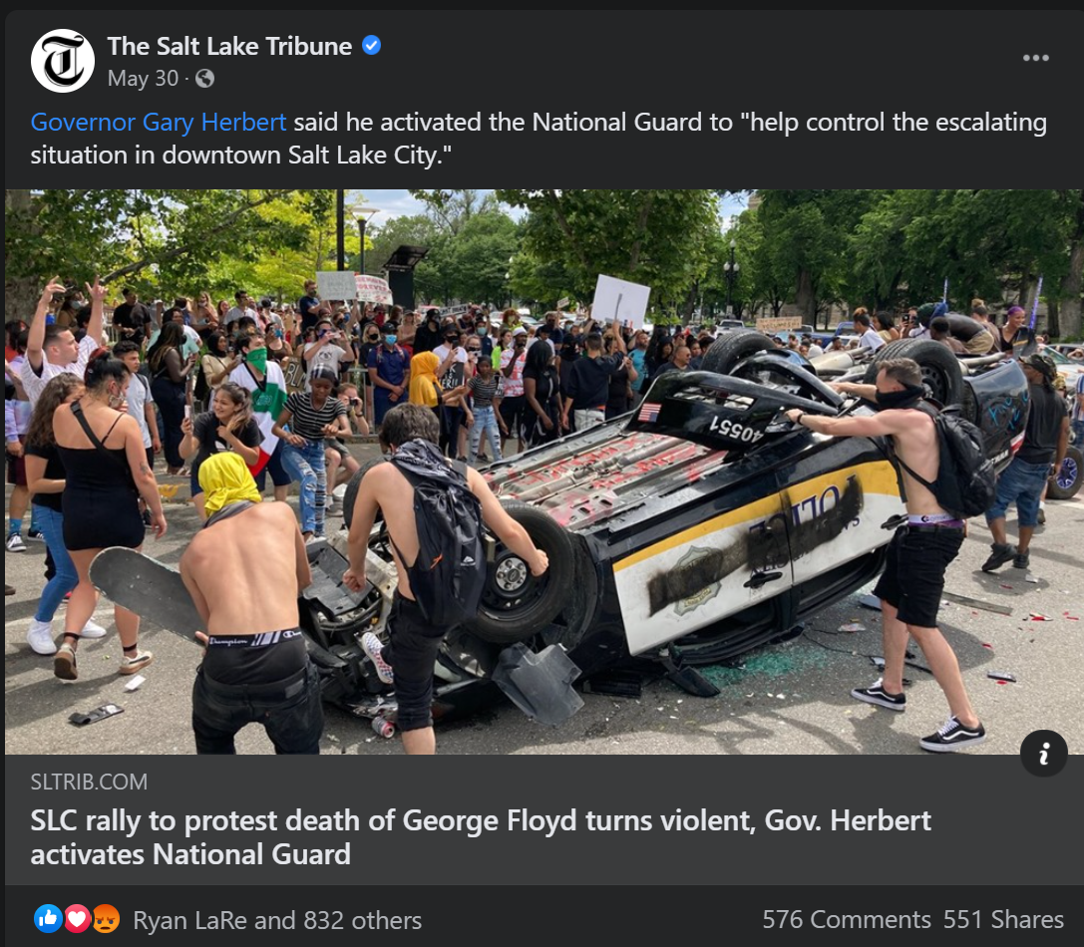

KSL News

* 5/29/2020 Article: Demonstrators peacefully protest for 'Justice for George Floyd' in downtown Salt Lake City (https://www.ksl.com/article/46758807)
  + Social Media Content: (Facebook post, posted 5/30/2020) ICYMI: Salt Lake City residents gathered to demand justice for George Floyd last night and continue today. "The problems happening in Minneapolis, Minnesota, are happening nationwide, and we want to make sure people understand that that's not an isolated problem." (https://www.facebook.com/kslcom/posts/10158843085879172)
  + Social Media Engagement: 211 reactions, 319 comments, 15 shares; sample of comments below:
    - What about “justice” for the young police officer in Ogden who gave his life while responding to a call for help? What about showing some gratitude for his selfless act and some sympathy and support for his family? That’s closer to home and to a real life circumstance here in Utah.
    - justice for him or them? He wouldn't want this. years from now, people will remember only that crimes were committed in his name and the family won't be able to heal because of it
    - Your protest made no sense, and it's completely irrelevant to the area. Not only is justice already being served to the officers actually involved, but SLC PD already proved they won't tolerate an officer abusing his power when they fired Payne. There was no (logical) reason to "protest"; stand in unity, yes, of course. But regardless, at least props to those who didn't start acting like tantrum-throwing babies and stayed peaceful.
    - SLC cannot give Floyd justice. I want justice for the riots in SLC. Justice for the damage caused by these riots. Justice for SLC!!!
  + Observations:
    - Headline and article are largely positive toward protests (not the case after latter half of May 30 protest – KSL coverage was very negative after that)
    - Despite that, comments are largely negative and condemn the protests
    - It also seems that a lot of commenters didn’t see this article until after the May 30 protest continued (which had “violence” = property damage) and were upset about the coverage that it was “peaceful”

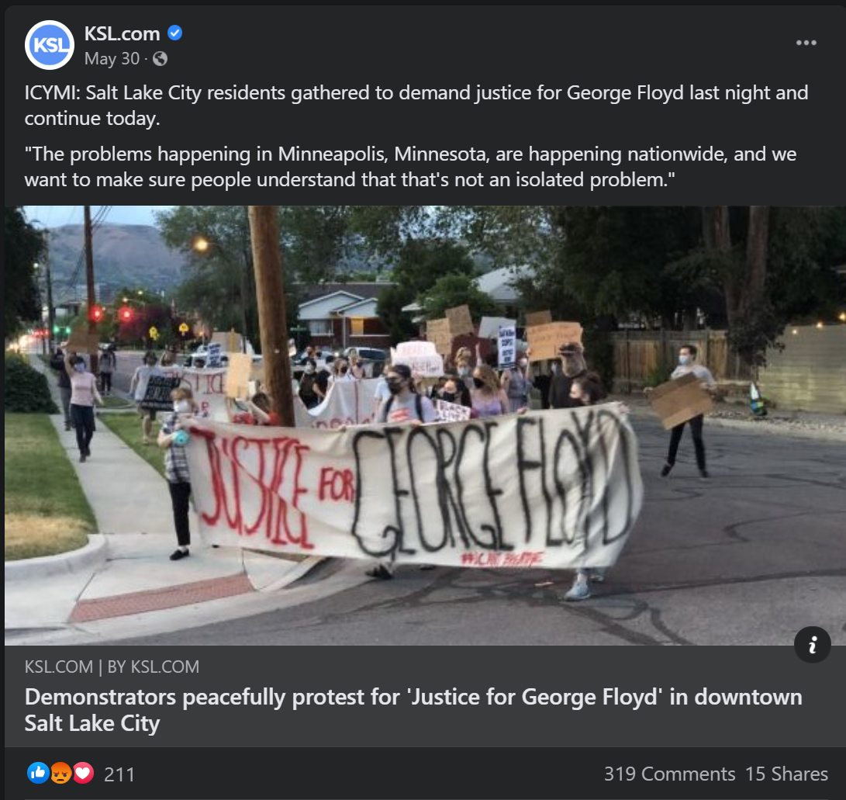

Deseret News

* 5/30/2020 Article: Salt Lake endures long day of protests as national anger over racism and the death of George Floyd grips the country (https://www.deseret.com/utah/2020/5/30/21275674/salt-lake-city-curfew-protest-library-square-george-floyd-killing-police-car-herbert-national-guard?utm_source=facebook&utm_medium=deseretnews&utm_campaign=facebookpage)
  + Social Media Content: (Facebook post) What started as a peaceful protest Saturday in downtown Salt Lake City against racism after the killing of George Floyd by police in Minneapolis turned more chaotic as the day went on. (<https://www.facebook.com/deseretnews/posts/10158409352234655>)
  + Social Media Engagement: 806 reactions, 552 comments, 146 shares; sample of comments below:
    - Peaceful? I'm so put off by this, the news,the people, it makes me ashamed of our state. I'm sure these are not the peace loving people that believe in love one another. The problem they were using didn't happen here. It happened in another state and had been adressed by the athorites. It was am excuse. Most of these people were not from here.
    - These people are out here burning up cars and burning down businesses are all funded by George Soros Hillary Clinton Barack Obama oh, the liberal Democratic Party and the Socialist. They were all expecting to have a wide support from the African American Community as well as other other ethnic groups and they're finding out they're not getting it it's turned on them and it will turn on the people that are funding this as well. These people that are out there doing this damage they think they are starting a new Revolution, in fact they don't have the brains enough to start a lawn mower. These people that are burning these cars and the tag of the police, would fall into a good category being Prime candidates of abortion at Birth. They serve no God accept Satan and we know who serve Satan and that's the liberal party. All I can say is God Bless America
    - Good. Let's keep it up!
    - Same old story through out history. Terrorist love Terror! They cloak it with a cause so they can carry out their terror. Rioters and looters love rioting and looting. And if they can attach a cause to it? Then they feel justified in their rioting and looting. Which is what they wanted to do the whole time. True Joy and Peace only comes from following and serving the Savior Jesus Christ! Help the poor and needy. Feed and cloth the hungry. As you serve and help others. True change happens to us all. Jesus Christ is the answer!
  + Observations:
    - Headline and post actually seem more neutral and positive towards the protest than other news coverage, but news article itself portrays the protest more negatively
    - Article seemed a lot more sympathetic to police officers – more attention on their efforts to stem the “violence”, interviews and quotes, etc.
    - Comments are very negative, but also extremely partisan and reference other partisan fights (George Soros, Hillary Clinton, etc.) in comparison to comments on KSL article
    - Interesting that the more neutral headline seems to have triggered more impassioned responses from the public than other news article posts on Facebook

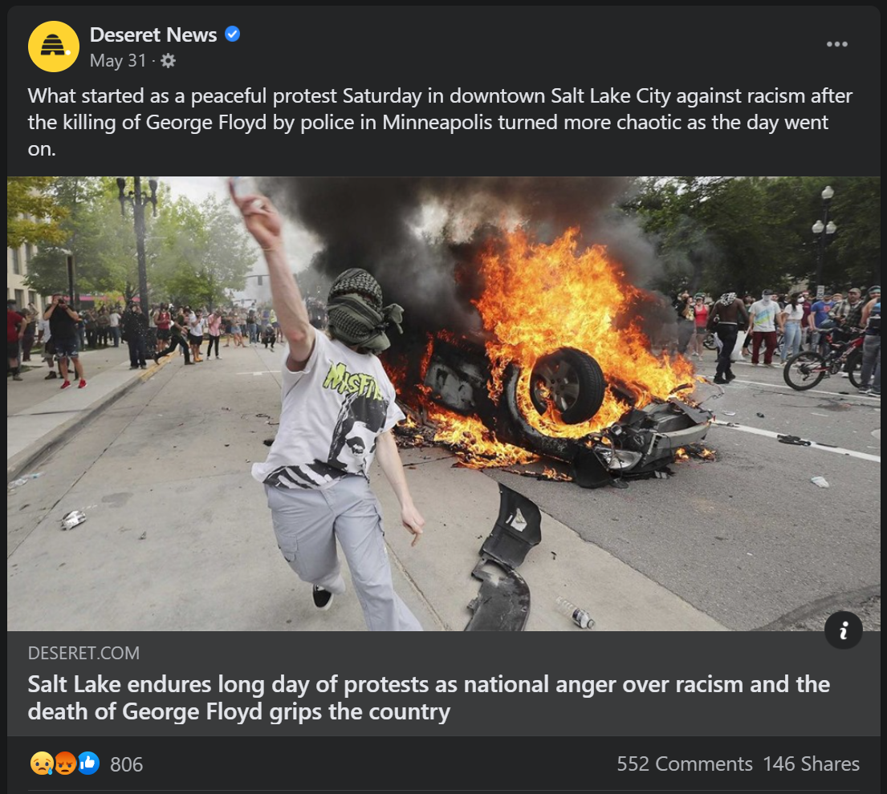

2. PROVO, UT

Daily Herald

* 6/6/2020 Article: Provo children learn to peacefully protest (https://www.heraldextra.com/news/local/central/provo/provo-children-learn-to-peacefully-protest/article_4b4b2146-4c61-55d4-97ee-bd44f24ba7c8.html)
  + Social Media Content: (Facebook post) “I told my daughter, if you don’t stand up for what’s right, you’re enabling the oppressor. I also made a point of asking for police to be there for the children to see police aren’t scary.” (<https://www.facebook.com/UtahValleyDailyHerald/posts/10157600944659366>)
  + Social Media Engagement: 143 reactions, 18 comments, 4 shares
    - The road to Hell is paved with good intentions...
    - Children have no place at a protest. Even a pretend one like this. They do not understand what is written on their signs. Let them be kids.
    - I would rather they read Common Sense, than be force-fed this...
    - Lots of meme and gif comments:
      * 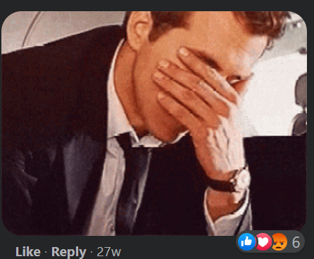
      * 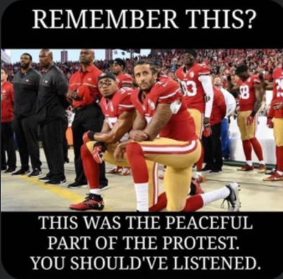
  + Observations:
    - Headline, post, and article are largely positive of the Black Lives Matter movement and protests
    - Comments are extremely negative, though less engagement than other news outlets
    - Meme and gif responses in the comments (in comparison to almost none in other news article posts on Facebook) suggest this outlet’s audience skews younger

